BERKSHIRE ORIENTEERS

SWINLEY EAST
Winter Series & Youth League Event (Local)

Saturday December 7th 2019

FINAL DETAILS

Berkshire Orienteers are pleased to welcome you to our event at Swinley East. Beginners and Juniors are particularly welcome. The area is heavily used by the local community so please be courteous and considerate to other users of the park, and please take careful note of the safety notices below.

Directions
Entrance is via Grid Ref: SU906661
Nearest Postcode: SL5 8AX
The event will be signposted from the turning into Buttersteep Rise on the A332 Swinley Road (this turning is 800m north of the roundabout with A322 Bracknell Road). Once you have turned in to Buttersteep Rise, follow the orienteering signs which will take you 800m via forest roads to the orienteering event. DO NOT PARK AT THE PUBLIC CAR PARK IN BUTTERSTEEP RISE.
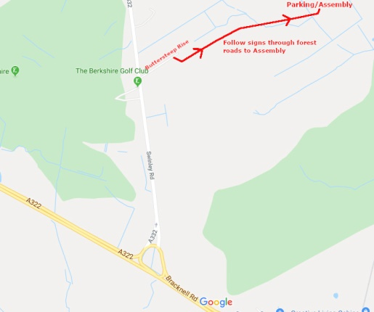

Parking
Parking is on the verges of forest tracks. In the event of heavy rainfall before the event, these verges may be muddy - please take care and listen to any instructions given by the car park volunteers. Please car-share if possible.

Assembly
Assembly is next to the car parking area.

Registration
Registration is from 10:00am - 11:00am. Entry is on the day. Prices are as follows:
 | Members | non-Members | EMIT Hire
Senior | £5 | £6 | £1.50
Junior | £2 | £3 | FREE

Electronic punching
EMIT electronic punching will be used with a punching start.
Lost EMIT cards will be charged at £45.

Dogs
Well-behaved dogs are allowed both on the course and assembly, but must be under control at all times and on a lead in Assembly area.

Planners Notes
Courses have been planned to avoid the worst of the Bracken but the light green and short blue courses will go through some areas where it is still quite high and will slow progress through the forest.

Maps
1:10,000

Courses
White, Yellow, Orange, Light Green and Short Blue

Starts
Start times are 10:30 - 11:30.
All starters must check their EMIT card using the MTR0 device as this provides a record of who is in the forest for safety purposes.
The start is metres from Assembly
There is no clothing dump.

Finish
The Finish is next to Assembly.
Courses close at 13:00.
Please ensure that you download even if you have not finished so that we don’t send out a search party.

Safety Notices
Swinley East is a public area that is popular with dog-walkers, mountain bikers and horse riders – please be aware of and courteous to other users during the race.

Please drive carefully along the forest tracks going to/from the event car park - these tracks are usually closed to traffic so users may not be expecting to encounter cars here.

Full arm and leg cover is required and cagoules may be required if the weather is bad. A whistle is advisable.

All competitors are advised to check body and clothing for ticks after the event. Ticks in this area have previously been found to carry Lyme’s Disease.

Competitors attending on their own should leave their car keys at Assembly during their run.

First Aid

First Aid for minor injuries is provided by BKO at the Assembly area. The nearest A&E is:
Frimley Park Hospital
Portsmouth Road
Camberley
Surrey
GU16 7UJ
Tel: 01276 604604

There is also a minor injuries centre at:
Bracknell Urgent Care Centre
Royal Berkshire Bracknell Healthspace
Eastern Gate
Brants Bridge
Bracknell
RG12 9TR
Tel: 01344551100

Results
Results will be displayed on BKO website shortly after the event.

Officials
Organiser: Doug and Annika Greenwood (BKO) events@bko.org.uk
Planner: Stefan Stasiuk (BKO) events@bko.org.uk

--------------------------------------------------------------------------------------------------------------------------
Competitors take part at their own risk.

The personal data you give will be used by the event organisers and their agents only for the purpose of processing and publishing the event entries and results, for conducting safety checks and to validate British Orienteering insurance cover. Submission of an entry for the event will indicate your acceptance of this procedure. In the event of cancellation we reserve the right to retain some or all of your entry fee to cover expenses.

